

………… . … CSE311 Section 4 …………………..……….

**Project Report**

**Hire-Worker**

**A One Stop Online Solution for**

**necessary daily Services**

|  |
| --- |
| Submitted To |
| Faculty Advisor | Intisar Tahmid Naheen (ITN) |
| Instructor | Nazmul Alam Dipto |

|  |
| --- |
| Submitted By |
| **Group 7** | Sudipta Mandal | 172 1489 042 |

**Introduction**

In recent times, online platform for different services is becoming very popular in our daily life. The users seek to have a one stop website for all kind of services. For example, plumber, electrician, lock-repairs etc. From the other side, the workers who seeks job for their own, also want a platform to provide their services. In the thought of linking these two sites, I come up with an idea name one-stop service providing solution. An online platform to link the customers with their service providers. For the perspective of Bangladesh, there is a huge scope for this kind of services.

**Functionality**

* Sign in/Registration
* Sign in as a customer
* Sign in as a worker
* Add service as a worker
* Customize worker profile
* Category Page to find all the services together
* Find a worker as a customer

**Methodology**

* HTML
* PHP
* CSS
* JavaScript
* MySQL
* APIs

**Designs Diagrams**

**Use Case:**

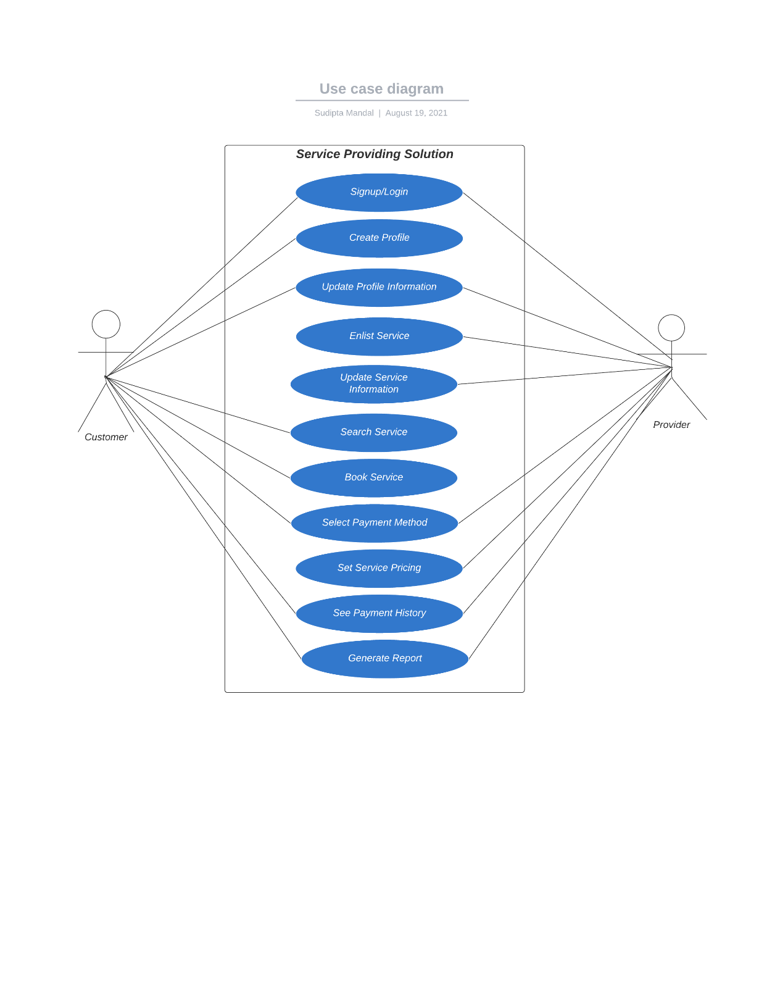

**ER Model:**

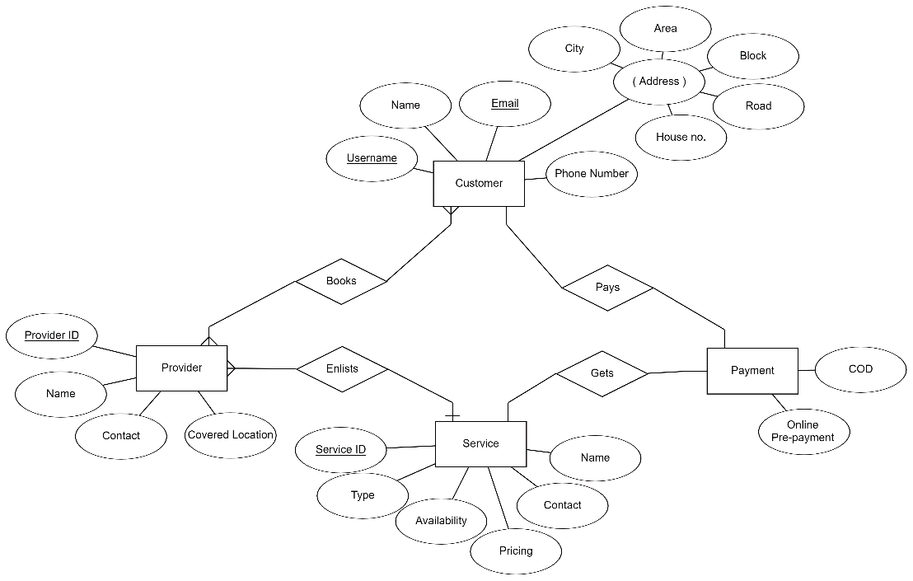

**DB Schema:**

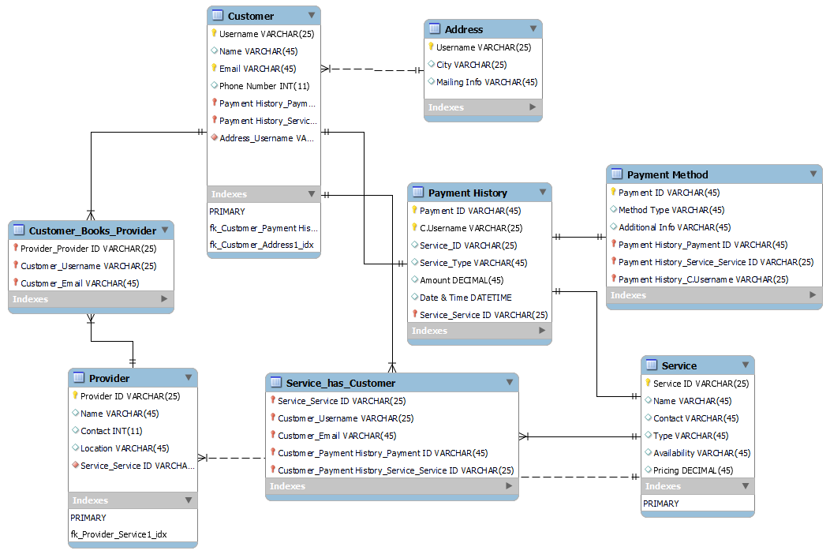

**Screen Shots:**



**Homepage**

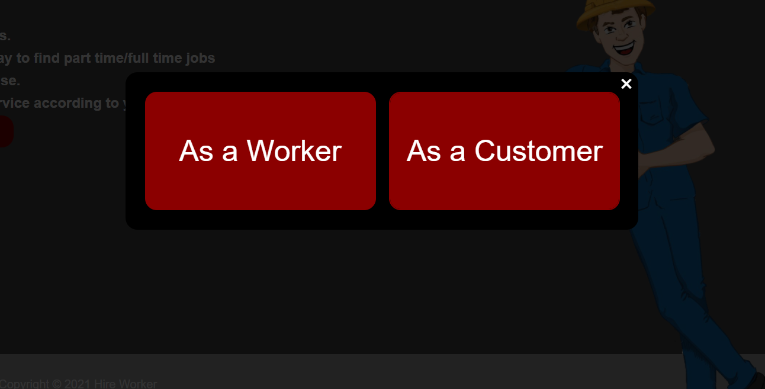

**Registration**

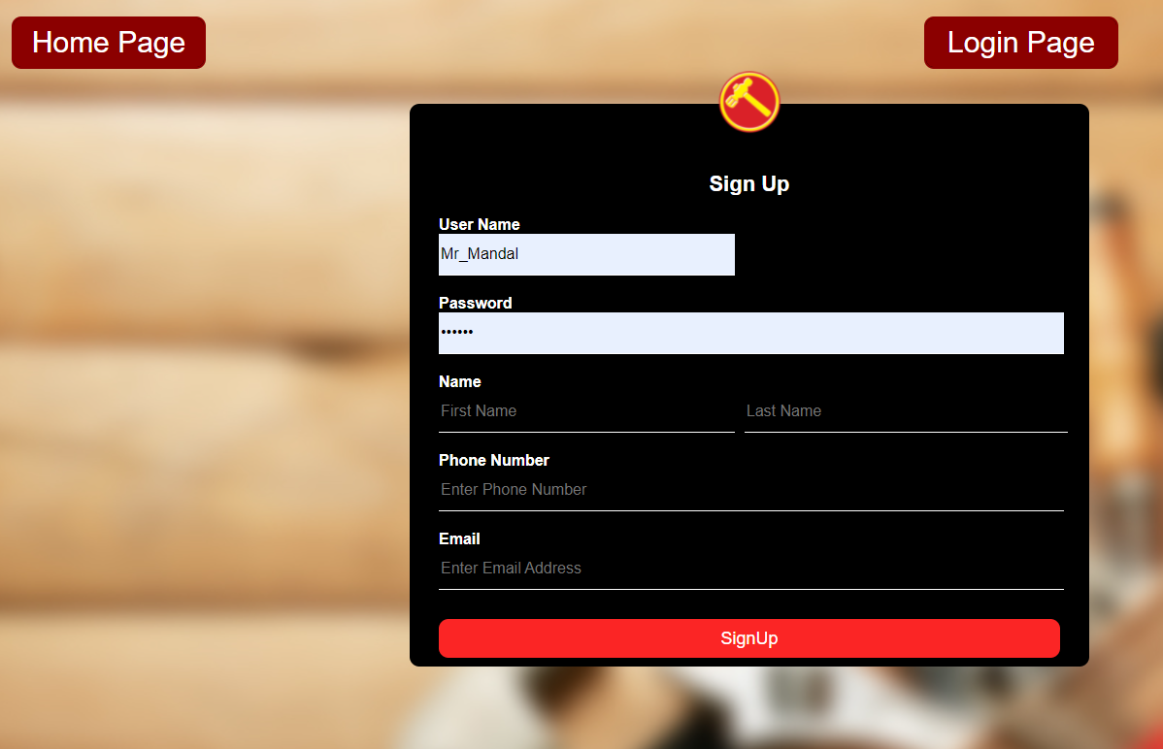

**As a Customer**

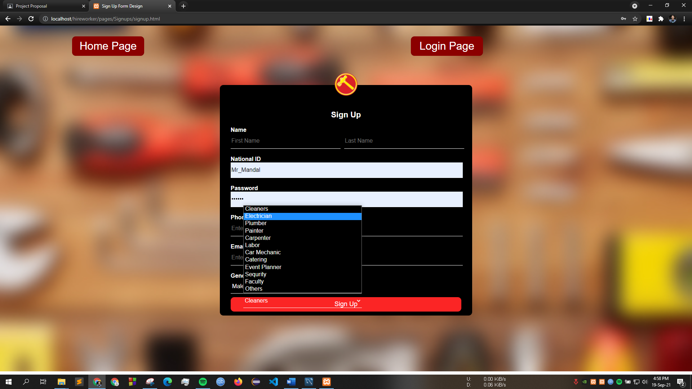

**As a Worker**

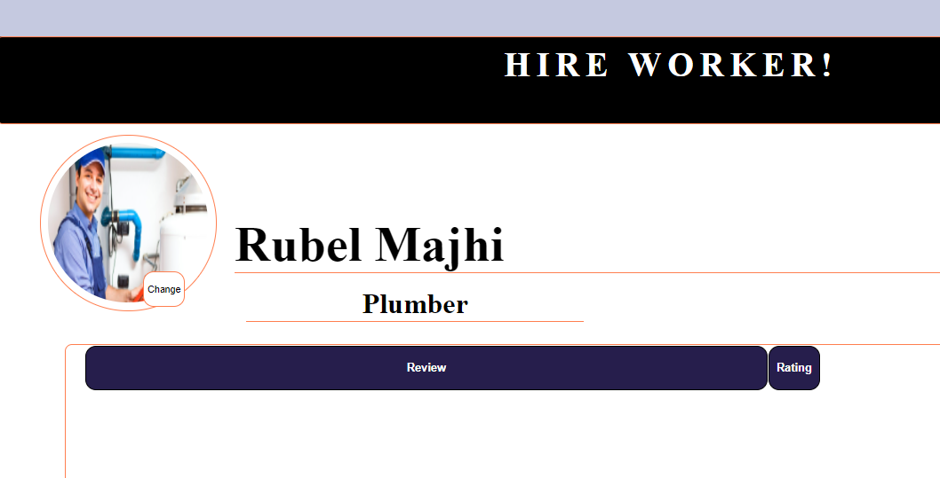

**Worker View**

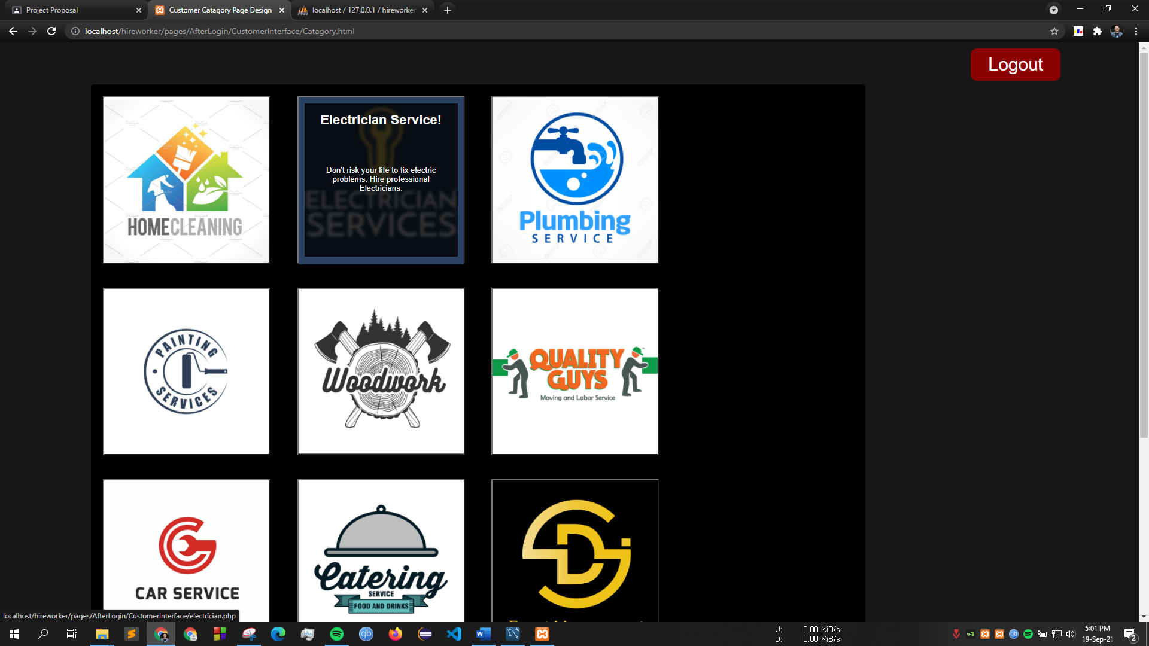

**Categories**

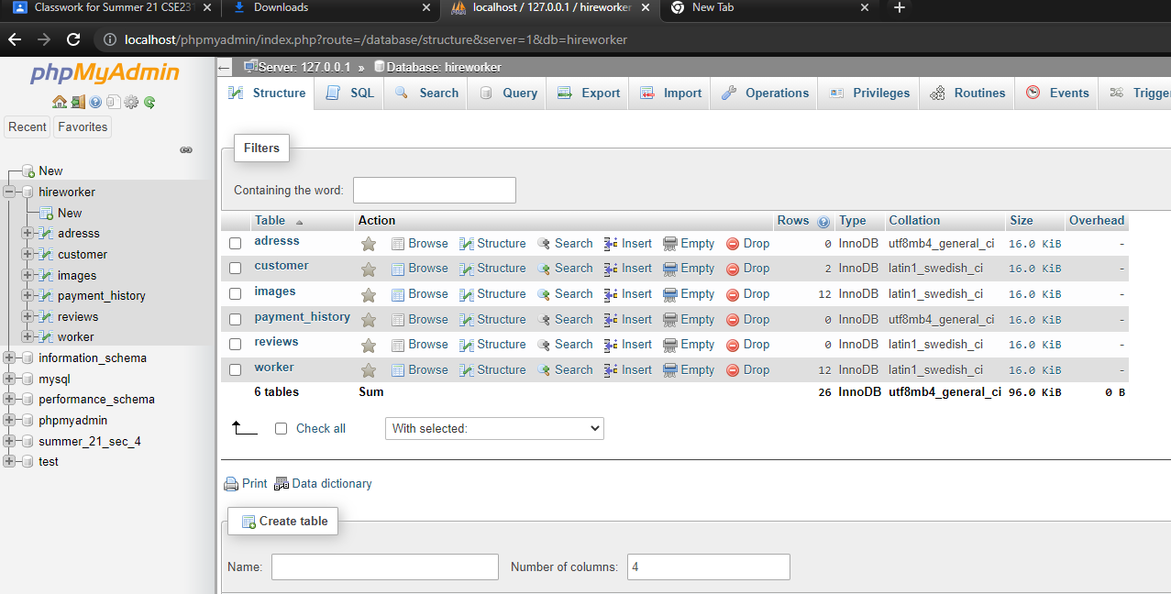

**Tables**

**Future Work & Vision**

For the semester being too short here are some things I am going to work on

in future on the website.

* Location based service – user friendly search system
* Bidding service – have a plan to add a bidding service for listed

works. Workers can set bidding price and

* Scheduled video call – want to add a video call service to connect

the customer and provider so that they can discuss issues and pricing face to face.